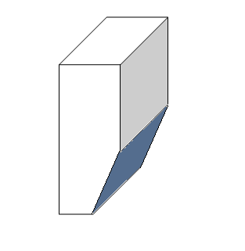
B

C

D

A

0

B

C

D

E

F

0

A

